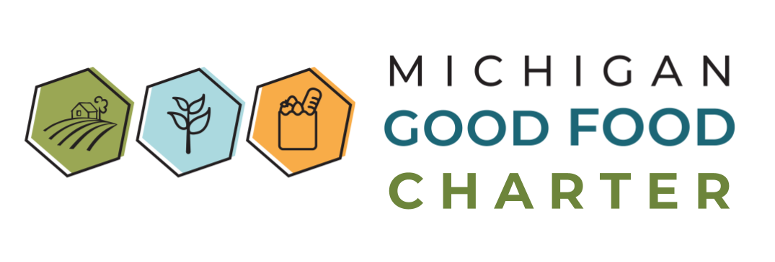

2022 Michigan Good Food Charter Resolution of Support
WHEREAS, Michigan has the second most diverse agricultural production in the country, and yet approximately 1.2 million Michiganders face food insecurity, nearly 300,000 of which are children; and
WHEREAS, Michigan communities of color experience disproportionate gaps in nutrition security, healthy and culturally relevant food access, as well as technical resources and lending opportunities for food and farm entrepreneurs of color; and
WHEREAS, Michigan’s $104.7 billion food and agriculture industry and its role accounting for about 17 percent of the state’s employment creates an unparalleled potential for community economic resilience; and
WHEREAS, Michigan consumers’ interest in local and regionally produced foods and yet an aging farming population combined with land consolidation and steep barriers to entry has steadily reduced the number of family farms and put control of land in fewer and fewer hands; and
WHEREAS, the prevalence of diet-related disease and the fact that our state falls above the seventy-fifth percentile nationally for annual statewide healthcare costs associated with food insecurity demands we address our system of growing, selling, and consuming food; and
WHEREAS, climate change is a growing threat, with many standard agricultural methods producing harmful greenhouse gas emissions, reducing biodiversity, and polluting watersheds; and BIPOC communities and low-wealth populations are disproportionately affected by the impacts of climate change;
BE IT THEREFORE RESOLVED that the undersigned endorses the vision of the Michigan Good Food Charter and supports policy and practice changes in the following areas to advance locally-integrated good food systems, ensuring food is accessible to everyone, promoting healthy communities, using fair and sustainable production methods, and supporting a diverse and equitable society as a means of achieving a healthier, more prosperous and more equitable state:
- Food Access to Food Sovereignty: Everyone has the resources to access and afford healthy, culturally relevant food where they live, work, learn, and play and the ability to shape the food systems that impact them.
- Farm and Food Business Viability: The food system supports a dynamic mix of local, regional, national, and global food sources that offer opportunities for small-scale and marginalized Michigan farm and food businesses to thrive.
- Health Equity: The food system supports opportunities for everyone to be as healthy as possible, physically, mentally, socially, and spiritually.
- Fair Wages and Economic Opportunity: People who plant, harvest, process, pack, transport, prepare, serve, and sell food have access to living wages, benefits, safe work environments, and pathways for career advancement and leadership.
- Sustainable Ecosystems: The food system protects air, water, and soil now and for future generations.
- Climate Change Mitigation and Resilience: Communities are resilient in the face of climate change and the food system actively mitigates its impact on the climate.
Organization Name:
 | (If signing as an individual or not applicable leave blank)
Contact Person’s Name:
Title or Position:
Street Address:
City: |  | State: |  | Zip:
Email: |  | Phone:

Individuals and organizations signing this resolution of support will be listed at www.michiganfood.org and this list will be presented to federal, state and local policymakers.
Please return by any of the following means:
- Email: crfs@msu.edu
- Mail: Lindsey Scalera - 303 Natural Resources, Michigan State University, East Lansing, MI 48824
- Online: https://www.canr.msu.edu/michiganfood/get-involved/resolution-of-support/
Please contact the above email address with any questions.

Feeding America. (2020). Map the Meal Gap - Michigan. https://map.feedingamerica.org/district/2020/overall/michigan
Carr, K.N., Polanco, V., Tyler, S. (2020). Michigan Farmers of Color and the Future of Sustainable Food Systems. Journal of Science Policy & Governance, vol. 17 (1). http://doi.org/10.38126/JSPG170102
Michigan Department of Agriculture and Rural Development. (n.d.). https://www.michigan.gov/mdard/about/mi-agriculture/michigan-agriculture-resources
Ferguson, R. (2021). Losing Ground: Farmland Consolidation and Threats to New Farmers, Black Farmers, and the Future of Farming. Union of Concerned Scientists. https://www.ucsusa.org/resources/losing-ground
Michigan Food Security Council. (2022). Final Report 2022. https://www.michigan.gov/mdhhs/assistance-programs/food
Office of Atmospheric Programs. (2021). Climate change and social vulnerability in the United States: A focus on six impacts. U.S. Environmental Protection Agency. https:// www.epa.gov/cira/social-vulnerability-report

